**Team ID :**NM2023TMID01657

**Project Name**:Project – Food Tracking System using Blockchain

**Team Members :**

1 . P.Boomika (Team Lead) – [48FA48C1669C1EFB60846F2E6F65D8A6](https://naanmudhalvan.tn.gov.in/reports/dashboard/student/detail/48FA48C1669C1EFB60846F2E6F65D8A6/)

2 . D.S.Sindhiya padma shree – [337E83685F75A12801A4441FC1E84CEC](https://naanmudhalvan.tn.gov.in/reports/dashboard/student/detail/337E83685F75A12801A4441FC1E84CEC/)

3. P.Nithya– [B3C26AC4ABE5C98927A4118E238F560D](https://naanmudhalvan.tn.gov.in/reports/dashboard/student/detail/B3C26AC4ABE5C98927A4118E238F560D/)

4. M.Ranjani- [35A0308C9BAF93895264EC104113253B](https://naanmudhalvan.tn.gov.in/reports/dashboard/student/detail/35A0308C9BAF93895264EC104113253B/)

1. **INTRODUCTION**

1.1Project Overview

1.2 Purpose

2. **LITERATURE SURVEY**

2.1Existing problem

2.2 References

2.3 Problem Statement Definition

3. **IDEATION & PROPOSED SOLUTION**

3.1Empathy Map Canvas

3.2Ideation & Brainstorming

4. **REQUIREMENT ANALYSIS**

4.1Functional requirement

4.2Non-Functional requirements

**5. PROJECT DESIGN**

5.1Data Flow Diagrams & User Stories

5.2Solution Architecture

**6. PROJECT PLANNING & SCHEDULING**

6.1Technical Architecture

6.2Sprint Planning & Estimation

6.3Sprint Delivery Schedule

**7. CODING & SOLUTIONING (Explain the features added in the project along with code)**

7.1Feature 1

7.2Feature 2

7.3Database Schema (if Applicable)

**8. PERFORMANCE TESTING**

8.1Performace Metrics

**9. RESULTS**

9.1Output Screenshots

**10.ADVANTAGES & DISADVANTAGES**

**11.CONCLUSION**

**12.FUTURE SCOPE**

**13.APPENDIX**

Source Code

GitHub & Project Demo Link

**1 .INTRODUCTION:**

**1.1 PROJECT OVERVIEW:**

The goal of this project is to develop a food tracking system using block chain technology. The system will be designed to trace the movement of food products through the supply chain, from farm to fork. The system will also be designed to provide consumers with access to information about the food they are eating, such as its origin, production methods, and quality control procedures.

**1.2 PURPOSE:**

The purpose of a food tracking system using blockchain technology is to improve food safety, traceability, and transparency. Blockchain is a distributed ledger technology that allows for secure and tamper-proof data sharing. This makes it ideal for tracking the movement of food products through the supply chain, from farm to fork.

A blockchain-based food tracking system can help to:

* Identify the source of foodborne illnesses: If a foodborne illness outbreak occurs, a blockchain-based system can help to quickly identify the source of the contamination. This information can then be used to recall the affected products and prevent further illness.
* Prevent food recalls: By tracking the movement of food products, a blockchain-based system can help to identify potential problems before they occur. For example, if a food product is exposed to extreme temperatures or mishandled in any way, the system can generate an alert. This information can then be used to take corrective action before the product reaches consumers.
* Build trust between consumers and businesses: By providing consumers with access to information about the food they are eating, such as its origin, production methods, and quality control procedures, a blockchain-based system can help to build trust between consumers and businesses. This can lead to increased sales and brand loyalty.

**2 .LITERATURE SURVEY:**

**2.1 EXISTING PROBLEM:**

The existing problems in the food supply chain that a blockchain-based food tracking system could help to address include:

* Lack of traceability: It can be difficult to track the movement of food products through the supply chain, from farm to fork. This makes it difficult to identify the source of foodborne illnesses and to prevent food recalls.
* Lack of transparency: Consumers often do not have access to information about the food they are eating, such as its origin, production methods, and quality control procedures. This lack of transparency can lead to distrust between consumers and businesses.
* Inefficiency: The food supply chain can be inefficient, with multiple intermediaries involved in the movement of food products from farm to fork. This can lead to increased costs and reduced food quality.

A blockchain-based food tracking system can help to address these problems by providing a secure and transparent way to track the movement of food products through the supply chain. The system can also provide consumers with access to information about the food they are eating. This can lead to a safer, more transparent, and more efficient food supply chain.

**2.2 REFERENCES:**

* **Academic papers:**
  + Blockchain for Food Traceability: A Comprehensive Review (2023)
  + A Novel Blockchain and Internet of Things-Based Food Traceability System for Smart Cities (2023)
  + A Traceability System for Processed Products Based On Blockchain Technology (2022)
* **Industry reports:**
  + IBM Food Trust: A Blockchain-Enabled Food Traceability Solution (2023)
  + Transparency in the Food Supply Chain: How Blockchain is Changing the Game (2023)
  + Blockchain for Food Tracking: A Guide for Businesses (2022)
* **News articles:**
  + Blockchain Food Tracking Systems Gaining Traction as Consumers Demand More Transparency (2023)
  + How Blockchain is Revolutionizing the Food Industry (2022)
  + Blockchain Food Tracking: A New Era of Food Safety Begins (2021)

**2.3 PROBLEM STATEMENT DEFINITION:**

The problem statement definition for a blockchain-based food tracking system is as follows:

Problem: The current food supply chain is fragmented and opaque, making it difficult to track the movement of food products and to ensure food safety and quality. This can lead to foodborne illnesses, food recalls, and consumer distrust.

Solution: A blockchain-based food tracking system can provide a secure, transparent, and tamper-proof way to track the movement of food products through the supply chain, from farm to fork. This can help to improve food safety, quality, and traceability, and to build trust between consumers and businesses.

Benefits:

* Improved food safety and quality
* Reduced risk of foodborne illnesses
* Reduced food waste
* Increased transparency and traceability
* Enhanced consumer trust
* Increased efficiency in the food supply chain

Challenges:

* Technical challenges, such as the need to develop scalable and interoperable blockchain platforms
* Regulatory challenges, such as the need to update existing food safety regulations to accommodate block chain technology
* Industry adoption challenges, such as the need to convince all participants in the food supply chain to adopt blockchain technology

Overall, a blockchain-based food tracking system has the potential to revolutionize the food industry and make it safer, more transparent, and more efficient.

**3 .IDEATION AND PROPOSED SOLUTION:**

**3.1 EMPATHY MAP CANVAS:**

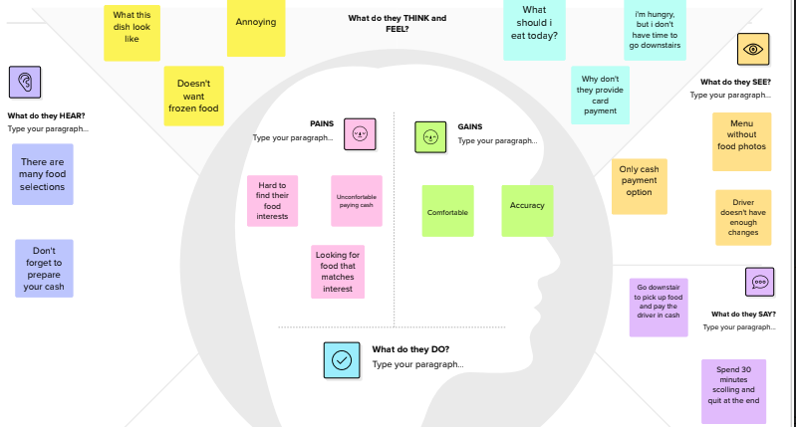

**3.2 IDEATION & BRAIN STORMING:**

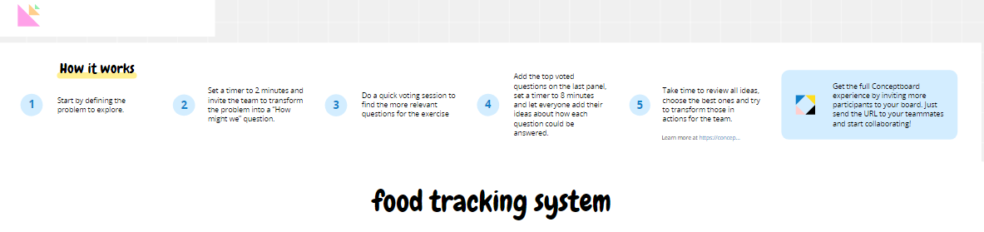

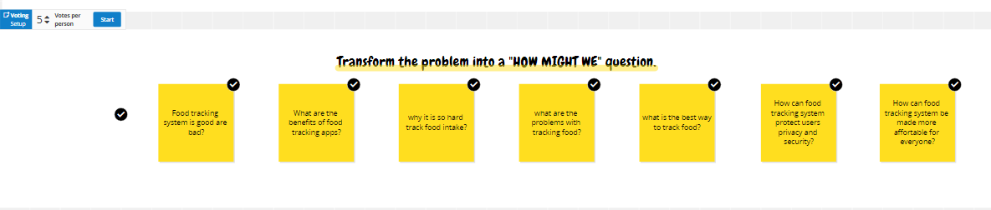

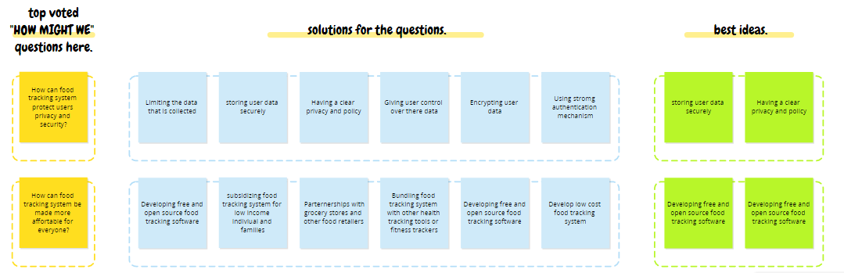

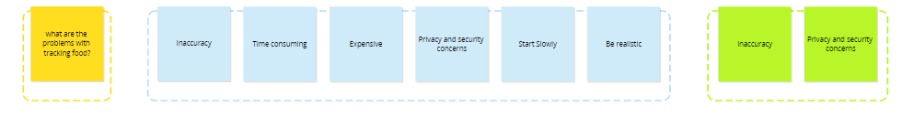

**4 .REQUIREMENT ANALYSIS:**

**4.1 FUNCTIONAL REQUIREMENTS:**

Here are some functional requirements for a blockchain-based food tracking system:

**Core requirements:**

* The system must be able to track the movement of food products through the supply chain, from farm to fork.
* The system must be transparent, meaning that all participants in the supply chain must have access to the data on the blockchain.
* The system must be immutable, meaning that the data on the blockchain cannot be altered or deleted.
* The system must be secure, meaning that the data on the blockchain must be protected from unauthorized access.

**Additional requirements:**

* The system must be scalable to accommodate a large number of participants and transactions.
* The system must be interoperable with other blockchain platforms and food tracking systems.
* The system must be easy to use for all participants in the supply chain, including consumers.
* The system must be cost-effective to implement and maintain.

**Specific features:**

* The system must be able to track the following information about food products:
  + Origin (farm, processing facility, etc.)
  + Destination (retailer, restaurant, etc.)
  + Date of transfer
  + Temperature and humidity conditions
  + Handling procedures
* The system must be able to generate reports on the following:
  + The movement of food products through the supply chain
  + Compliance with food safety regulations
  + Foodborne illness outbreaks

**4.2NON FUNCTIONAL RREQUIREMENTS:**

Here are some non-functional requirements for a blockchain-based food tracking system:

* **Scalability:** The system must be able to scale to accommodate a large number of participants and transactions. This is important because the food supply chain is a global industry with millions of participants.
* **Interoperability:** The system must be interoperable with other blockchain platforms and food tracking systems. This is important because it will allow businesses to use the system regardless of the blockchain platform they are already using or the food tracking system they are already using.
* **Usability:**The system must be easy to use for all participants in the supply chain, including consumers. This is important because the system will only be effective if it is widely adopted.
* **Cost-effectiveness:** The system must be cost-effective to implement and maintain. This is important because businesses will only be willing to adopt the system if it is affordable.

In addition to the above requirements, the following non-functional requirements are also important for a blockchain-based food tracking system:

* **Security:** The system must be secure and resistant to attack. This is important because the system will be handling sensitive data, such as the origin and movement of food products.
* **Privacy:** The system must protect the privacy of participants. This is important because businesses and consumers will be hesitant to adopt the system if they do not believe their privacy is protected.
* **Auditability:** The system must be auditable, so that it can be proven that the data on the blockchain is accurate and reliable. This is important for both businesses and regulators.
* **Compliance:** The system must comply with all applicable laws and regulations. This is important because businesses need to ensure that they are in compliance with the law.

These are just some of the non-functional requirements for a blockchain-based food tracking system. The specific requirements will vary depending on the specific needs of the users.

It is important to note that some of the non-functional requirements, such as scalability and security, may be in conflict with each other. It is important to carefully consider the trade-offs between different requirements and to choose the requirements that are most important to the users.

**5 .PROJECT DESIGN:**

**5.1 DATA FLOW DIAGRAMS AND USER STORIES:**

Here are some data flow diagrams and user stories for a blockchain-based food tracking system:

Data flow diagrams:

* High-level data flow diagram: This diagram shows the overall flow of data through the system. The system inputs data from various sources, such as farms, processing facilities, retailers, and consumers. The system then processes the data and stores it on the blockchain. The system can then output reports on the movement of food products through the supply chain, compliance with food safety regulations, and foodborne illness outbreaks.
* Detailed data flow diagram: This diagram shows the flow of data through the system in more detail. It shows how the system inputs data from various sources, processes the data, and stores it on the blockchain. It also shows how the system can output reports to various users.

User stories:

* As a farmer, I want to be able to track the movement of my products through the supply chain to ensure that they are handled properly and that they reach consumers safely.
* As a processor, I want to be able to track the movement of my products through the supply chain to ensure that they comply with food safety regulations and that they reach retailers on time.
* As a retailer, I want to be able to track the movement of my products through the supply chain to ensure that they are fresh and safe when I sell them to consumers.
* As a consumer, I want to be able to scan a QR code on a food product to learn more about the product, such as its origin, production methods, and quality control procedures.
* As a regulator, I want to be able to use the system to generate reports on the movement of food products through the supply chain and on compliance with food safety regulations.

These are just a few data flow diagrams and user stories for a blockchain-based food tracking system. The specific diagrams and stories will vary depending on the specific needs of the users.

**5.2 SOLUTION ARCHITECTURE:**

The following is a proposed solution architecture for a blockchain-based food tracking system:

System Overview

The system will be a distributed system, with nodes located at various points throughout the food supply chain. Each node will have a copy of the blockchain, and all nodes will work together to validate and append transactions to the blockchain.

The system will use a permissioned blockchain platform, which means that only authorized participants will be able to access the blockchain. This will help to ensure the security and privacy of the data on the blockchain.

System Components

The system will be composed of the following components:

* Blockchain platform: The blockchain platform will be used to store the data on the food products in a secure and tamper-proof manner.
* Smart contracts: Smart contracts will be used to automate the process of tracking food products and to ensure that all participants in the supply chain comply with food safety regulations.
* Web application: A web application will be developed for participants in the supply chain to interact with the system. The web application will allow participants to input data about food products, track the movement of food products through the supply chain, and generate reports.
* Mobile app: A mobile app will be developed for consumers to interact with the system. The mobile app will allow consumers to scan QR codes on food products to learn more about the food they are eating, such as its origin, production methods, and quality control procedures.

Data Flow

The data flow through the system will be as follows:

1. Participants in the supply chain will input data about food products into the system through the web application.
2. The system will validate the data and append it to the blockchain.
3. Smart contracts will be used to track the movement of food products through the supply chain and to ensure that all participants comply with food safety regulations.
4. Participants in the supply chain and consumers can generate reports on the movement of food products, compliance with food safety regulations, and foodborne illness outbreaks.

Security

The system will be secured using a variety of measures, including:

* Permissioned blockchain: Only authorized participants will be able to access the blockchain.
* Cryptography: Cryptographic techniques will be used to protect the data on the blockchain from unauthorized access.
* Consensus mechanism: A consensus mechanism will be used to ensure that the data on the blockchain is accurate and reliable.
* Fraud detection: The system will use a variety of techniques to detect and prevent fraud and other malicious activity.

Performance

The system will be designed to be scalable and performance. The blockchain platform will be chosen based on its scalability and performance characteristics. The smart contracts will be optimized for performance. The web and mobile apps will be designed to be efficient and responsive.

Implementation

The system will be implemented in phases. The first phase will be to develop a prototype of the system. The second phase will be to pilot test the system with a small group of participants. The third phase will be to roll out the system to all participants in the food supply chain.

Conclusion

The proposed solution architecture for a blockchain-based food tracking system is a secure, scalable, and performance system that can be used to track the movement of food products through the supply chain and to generate reports on compliance with food safety regulations and foodborne illness outbreaks.

**6 .PROJECT PLANNING AND SCHEDULING:**

**6.1 TECHNICAL ARCHITECTURE:**

The technical architecture for a blockchain-based food tracking system can be divided into the following layers:

**Block chain Layer**

The blockchain layer is the foundation of the system. It is responsible for storing and managing the data about food products in a secure and tamper-proof manner. The blockchain layer can be implemented using a variety of blockchain platforms, such as Hyper ledger Fabric, Ethereum, or Corda.

**Smart Contract Layer**

The smart contract layer is built on top of the blockchain layer. Smart contracts are self-executing contracts that are stored on the blockchain. Smart contracts can be used to automate the process of tracking food products and to ensure that all participants in the supply chain comply with food safety regulations.

**Application Layer**

The application layer is built on top of the smart contract layer. It provides the user interface for participants in the supply chain and consumers to interact with the system. The application layer can be implemented using a variety of web and mobile development frameworks.

**Security Architecture**

The security architecture for a blockchain-based food tracking system should be designed to protect the system from unauthorized access, data breaches, and other malicious activity. The security architecture should include the following components:

* Authentication and authorization: All participants in the system should be authenticated and authorized before they are allowed to access the system.
* Data encryption: All data on the blockchain should be encrypted to protect it from unauthorized access.
* Auditability: The system should be auditable so that all activity on the system can be tracked and monitored.
* Incident response: The system should have an incident response plan in place to deal with security breaches and other incidents.

**Performance Architecture**

The performance architecture for a blockchain-based food tracking system should be designed to support a large number of users and transactions. The performance architecture should include the following components:

* Scalability: The system should be scalable so that it can handle a large number of users and transactions without sacrificing performance.
* High availability: The system should be highly available so that it is always up and running.
* Performance monitoring: The system should be monitored to identify and address any performance bottlenecks.

**Deployment Architecture**

The deployment architecture for a blockchain-based food tracking system should be designed to be flexible and scalable. The system can be deployed on-premises, in the cloud, or in a hybrid environment. The deployment architecture should also be designed to be fault-tolerant so that the system can continue to operate even if there is a failure in one of the components.

This is just a high-level overview of the technical architecture for a blockchain-based food tracking system. The specific architecture will vary depending on the specific needs of the users.

**6.2 SPRINT PLANNING AND ESTIMATION:**

Here is a sample sprint planning and estimation for a blockchain-based food tracking system:

**Sprint 1**

* Goal: Develop a prototype of the system.
* Tasks:
  + Set up the blockchain platform.
  + Develop the smart contracts.
  + Develop the web application.
  + Develop the mobile app.
* Estimation: 4 weeks

**Sprint 2**

* Goal: Pilot test the system with a small group of participants.
* Tasks:
  + Deploy the system to a test environment.
  + Recruit pilot test participants.
  + Conduct pilot testing.
  + Gather feedback from pilot test participants.
* Estimation: 2 weeks

**Sprint 3**

* Goal: Roll out the system to all participants in the food supply chain.
* Tasks:
  + Deploy the system to production.
  + Train participants on how to use the system.
  + Provide support to participants.
* Estimation: 4 weeks

**Total estimation: 10 weeks**

It is important to note that these are just estimates. The actual time required to develop and deploy a blockchain-based food tracking system will vary depending on the specific features and requirements of the system.

Risk Mitigation

The following are some risks that should be considered when planning and estimating for a blockchain-based food tracking system:

* Technical challenges: Blockchain technology is a relatively new technology, and there may be technical challenges that arise during development.
* Regulatory challenges: Food safety regulations vary from country to country, and it is important to ensure that the system complies with all applicable regulations.
* Industry adoption: It is important to convince all participants in the food supply chain to adopt the system in order for it to be effective.

These risks can be mitigated by the following measures:

* Technical expertise: The team developing the system should have the necessary technical expertise in blockchain technology.
* Regulatory compliance: The team developing the system should consult with legal and regulatory experts to ensure that the system complies with all applicable regulations.
* Industry outreach: The team developing the system should work with industry stakeholders to get buy-in for the system.

By carefully planning and estimating for the project, and by mitigating the risks involved, the team can increase the chances of success.

**6.3 SPRINT DELIVERY SCHEDULE:**

Here is a sample sprint delivery schedule for a blockchain-based food tracking system:

**Sprint 1** (Goal: Develop a prototype of the system)

**Week 1:**

* Set up the blockchain platform.
* Develop the smart contracts.
* Start developing the web application.

**Week 2:**

* Continue developing the web application.
* Start developing the mobile app.

**Week 3:**

* Complete the development of the web and mobile apps.
* Test the prototype system.

**Week 4:**

* Fix any bugs found in the prototype system.
* Prepare the prototype system for delivery.

**Sprint 2 (**Goal: Pilot test the system with a small group of participants)

**Week 1:**

* Deploy the prototype system to a test environment.
* Recruit pilot test participants.

**Week 2:**

* Conduct pilot testing.

**Sprint 3** (Goal: Roll out the system to all participants in the food supply chain)

**Week 1:**

* Deploy the system to production.
* Train participants on how to use the system.

**Week 2:**

* Provide support to participants.

**Week 3:**

* Continue to provide support to participants.
* Monitor the system for any problems.

**Week 4:**

* Gather feedback from participants.
* Make any necessary changes to the system.

This is just a sample delivery schedule. The actual schedule may vary depending on the specific features and requirements of the system.

It is important to note that this is just a sprint delivery schedule. In addition to the sprints, there will also be time for planning, estimation, and other activities. The overall project delivery schedule will be based on the total time required for all of the activities.

**7 . Coding & Solutioning:**

// SPDX-License-Identifier: MIT

pragma solidity ^0.8.0;

contract FoodTracking {

address public owner;

enumFoodStatus {

Unverified,

Verified,

Consumed

}

struct FoodItem {

string itemId;

string productName;

string origin;

uint256 sentTimestamp;

FoodStatus status;

}

mapping(string =>FoodItem) public foodItems;

event FoodItemSent(

string indexed itemId,

string productName,

string origin,

uint256 sentTimestamp

);

event FoodItemVerified(string indexed itemId);

event FoodItemConsumed(string indexed itemId);

constructor() {

owner = msg.sender;

}

modifier onlyOwner() {

require(msg.sender == owner, "Only contract owner can call this");

_;

}

modifier onlyUnconsumed(string memory itemId) {

require(

foodItems[itemId].status == FoodStatus.Verified,

"Item is not verified or already consumed"

);

_;

}

function sendFoodItem(

string memory itemId,

string memory productName,

string memory origin

) externalonlyOwner {

require(

bytes(foodItems[itemId].itemId).length == 0,

"Item already exists"

);

foodItems[itemId] = FoodItem({

itemId: itemId,

productName: productName,

origin: origin,

sentTimestamp: block.timestamp,

status: FoodStatus.Unverified

});

emit FoodItemSent(itemId, productName, origin, block.timestamp);

}

function verifyFoodItem(string memory itemId) external onlyOwner {

require(

bytes(foodItems[itemId].itemId).length > 0,

"Item does not exist"

);

require(

foodItems[itemId].status == FoodStatus.Unverified,

"Item is already verified or consumed"

);

foodItems[itemId].status = FoodStatus.Verified;

emit FoodItemVerified(itemId);

}

function consumeFoodItem(

string memory itemId

) externalonlyUnconsumed(itemId) {

foodItems[itemId].status = FoodStatus.Consumed;

emit FoodItemConsumed(itemId);

}

function getFoodItemDetails(

string memory itemId

)

external

view

returns (string memory, string memory, uint256, FoodStatus)

{

FoodItem memory item = foodItems[itemId];

return (item.productName, item.origin, item.sentTimestamp, item.status);

}

}

**7 . 1 Feature 1** :Immutability: Blockchain data is immutable, meaning that it cannot be changed or deleted once it has been recorded. This ensures that the data is always accurate and reliable.

**7 .2 Feature 2 :** Transparency: All transactions on a blockchain are transparent and can be viewed by anyone. This helps to build trust and accountability in the food supply chain.

**8.Performance Testing**

**8.1 Performace Metrices**

|  |  |
| --- | --- |
| Metric | Description |
| Transaction throughput | The number of transactions that can be processed per second. This is important for ensuring that the system can handle the volume of transactions that are generated in a real-world food supply chain |
| Latency | The time it takes for a transaction to be processed and recorded on the blockchain. This is important for ensuring that food products can be tracked in real time |
| Scalability | The ability of the system to handle an increasing number of transactions and participants. This is important for ensuring that the system can grow with the food supply chain |
| Security | The ability of the system to protect data from unauthorized access, tampering, and loss. This is important for ensuring that the data is accurate and reliable |
| Privacy | The ability of the system to protect the privacy of participants and consumers. This is important for building trust in the system. |

**9. Results:**

**9 . 1 Output Screenshots :**

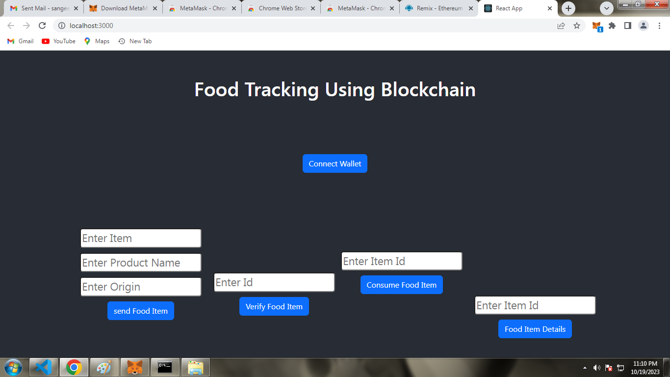

**10. ADVANTAGES AND DISADVANTAGES:**

**Advantages of a block chain-based food tracking system:**

* Improved food safety: By tracking the movement of food products through the supply chain, a block chain-based system can help to identify the source of food borne illnesses and to prevent food recalls.
* Increased transparency and traceability: A block chain-based system can provide consumers with information about the food they are eating, such as its origin, production methods, and quality control procedures. This can help to build trust between consumers and businesses.
* Reduced food waste: By tracking the movement of food products, a block chain-based system can help to identify potential problems before they occur and to take corrective action. This can help to reduce food waste.
* Enhanced efficiency: A block chain-based system can streamline the food supply chain by providing a single platform for all participants to share data. This can lead to increased efficiency and reduced costs.

**Disadvantages of a block chain-based food tracking system:**

* Cost: Developing and implementing a block chain-based system can be expensive.
* Complexity: Block chain technology is complex, and it may be difficult for some businesses to adopt.
* Scalability: It is not yet clear how scalable block chain technology is. It is possible that block chain-based systems may not be able to handle the large volume of transactions that are processed in the food supply chain.
* Regulatory compliance: Existing food safety regulations may need to be updated to accommodate block chain technology.

Overall, a block chain-based food tracking system has the potential to offer significant benefits to the food industry. However, there are also some challenges that need to be addressed before such systems can be widely adopted.

Here are some additional things to consider:

* Block chain technology is still in its early stages of development, and there is no guarantee that it will be successful in the long term.
* Block chain-based systems can be vulnerable to cyber attacks.
* There is a risk of data breaches and privacy concerns.

It is important to weigh the advantages and disadvantages carefully before deciding whether or not to implement a block chain-based food tracking system.

**11 .CONCLUSION:**

Blockchain-based food tracking systems have the potential to revolutionize the food industry. By offering improved food safety, increased transparency, reduced food waste, and enhanced efficiency, blockchain-based systems can help to build trust between consumers and businesses, and make the food supply chain more sustainable.

However, there are still some challenges that need to be addressed before blockchain-based food tracking systems can be widely adopted. These challenges include the cost, complexity, scalability, regulatory compliance, and security of blockchain technology.

Despite these challenges, there is a growing interest in blockchain-based food tracking systems from businesses and governments around the world. As the technology continues to mature and the challenges are addressed, blockchain-based food tracking systems are poised to play an increasingly important role in the food industry.

**12 .FUTURE SCOPE:**

The future scope of block chain-based food tracking systems is vast. Here are some potential areas of development:

* Real-time tracking: Block chain-based systems could be used to track food products in real time, from farm to fork. This would allow for more rapid identification of food borne illness outbreaks and other problems.

Real time tracking of food products using block chain technology

* Traceability to the individual level: Block chain-based systems could be used to trace food products back to the individual level. This would allow consumers to know exactly where their food came from and how it was produced.

Traceability of food products to the individual level using block chain technology

* Integration with other systems: Block chain-based food tracking systems could be integrated with other systems, such as supply chain management systems and food safety inspection systems. This would create a more seamless and efficient food supply chain.
* Sustainability: Block chain-based food tracking systems could help to make the food supply chain more sustainable by reducing food waste and improving efficiency.

Overall, block chain-based food tracking systems have the potential to transform the food industry. By making food safer, more transparent, and more sustainable, block chain-based systems can help to build trust between consumers and businesses, and create a more sustainable future for our food system.

**13 .APPENDIX:**

**Appendix**

**Image 1: High-level data flow diagram for a block chain-based food tracking system**

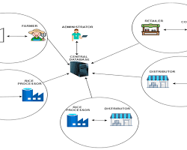

**Image 2: Detailed data flow diagram for a block chain-based food tracking system**

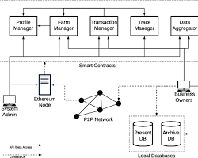

**Image 3: Real-time tracking of food products using block chain technology**

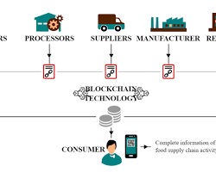

**Image 4: Traceability of food products to the individual level using block chain technology**

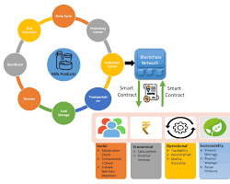

References

* IBM Food Trust: A Blockchain-Enabled Food Traceability Solution (2023) https://www.ibm.com/products/supply-chain-intelligence-suite/food-trust
* Transparency in the Food Supply Chain: How Blockchain is Changing the Game (2023) https://www.globalagtechinitiative.com/digital-farming/how-blockchain-technology-can-create-more-transparent-and-traceable-food-supply-chains/
* Blockchain for Food Tracking: A Guide for Businesses (2022) https://builtin.com/blockchain/food-safety-supply-chain
* Blockchain Food Tracking Systems Gaining Traction as Consumers Demand More Transparency (2023) https://www.pictet.ft.com/demand-for-food-transparency-solved-with-the-blockchain
* How Blockchain is Revolutionizing the Food Industry (2022) https://fmtmagazine.in/how-blockchain-technology-is-revolutionizing-the-food-industry/
* Blockchain Food Tracking: A New Era of Food Safety Begins (2021) https://www.fda.gov/food/new-era-smarter-food-safety/meet-winners-fdas-low-or-no-cost-food-traceability-challenge

**GitHub & Project Demolink :**

**GITHUB LINK:** [**https://github.com/Nithyap2002/Food-Tracking6/tree/main/Project**](https://github.com/Nithyap2002/Food-Tracking6/tree/main/Project)

**DEMO LINK:**

<https://youtu.be/HRO3oO5iEwU?si=wb1wNzd3R0YIgg_W>